TASKS ON VPC – 26/08

- Create VPC with 2 private and 2 public subnets..

Objective
Create a custom VPC and divide its network into 2 public subnets and 2 private subnets across two Availability Zones.
VPC Configuration
Resource | Name / CIDR
VPC Name | my-devops-vpc
VPC CIDR | 192.168.0.0/24
Subnet Configuration
Subnet Name | Type | CIDR Block | Availability Zone
public-subnet-1 | Public | 192.168.0.0/26 | AZ-1
public-subnet-2 | Public | 192.168.0.64/26 | AZ-2
private-subnet-1 | Private | 192.168.0.128/26 | AZ-1
private-subnet-2 | Private | 192.168.0.192/26 | AZ-2
Steps Performed
- Opened the AWS Management Console.
- Navigated to VPC Dashboard → Your VPCs.
- Clicked Create VPC.
- Selected VPC only.
- Entered the VPC name as my-devops-vpc.
- Configured the IPv4 CIDR block as 192.168.0.0/24.
- Created the VPC.
- Navigated to VPC Dashboard → Subnets.
- Created public-subnet-1 with CIDR 192.168.0.0/26.
- Created public-subnet-2 with CIDR 192.168.0.64/26.
- Created private-subnet-1 with CIDR 192.168.0.128/26.
- Created private-subnet-2 with CIDR 192.168.0.192/26.
- Verified that all four subnets were successfully created inside my-devops-vpc.

VPC
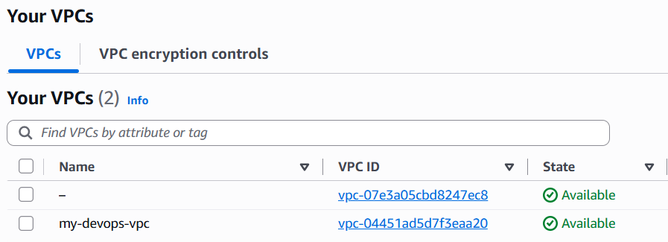
SUBNETS
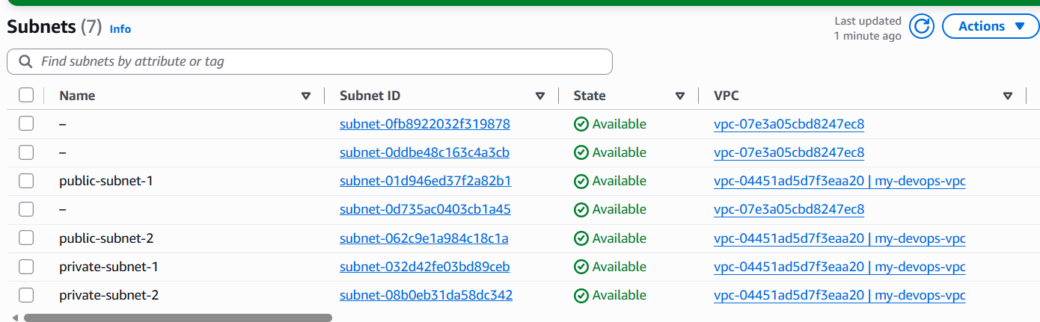

- Enable DNS Hostname in VPC..

Objective
Enable DNS Resolution and DNS Hostnames for the custom VPC so that instances launched inside the VPC can use DNS names.
Steps Performed
- Opened the AWS Management Console.
- Navigated to VPC Dashboard → Your VPCs.
- Selected the VPC:
my-devops-vpc
- Opened Actions → Edit VPC settings.
- Enabled DNS resolution.
- Enabled DNS hostnames.
- Clicked Save changes.
- Verified that both DNS settings were enabled.
Verification
Setting | Status
DNS Resolution | Enabled
DNS Hostnames | Enabled

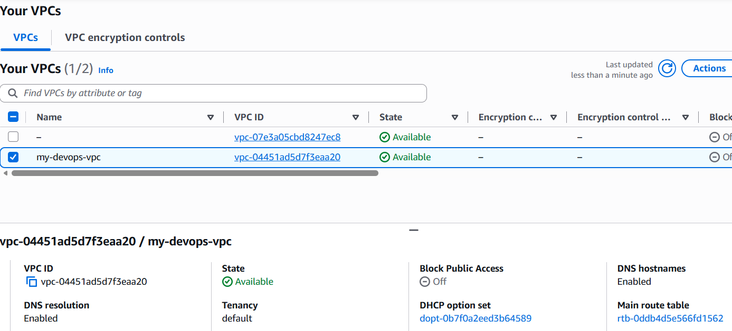
- Enable Auto Assign Public IP in 2 public subnets..

Objective
Enable automatic assignment of public IPv4 addresses for the two public subnets so that EC2 instances launched in these subnets can automatically receive a public IP address.
Steps Performed
- Navigated to AWS Console → VPC → Subnets.
- Selected public-subnet-1.
- Clicked Actions → Edit subnet settings.
- Enabled Auto-assign public IPv4 address.
- Saved the changes.
- Repeated the same steps for public-subnet-2.
- Verified that automatic public IPv4 address assignment was enabled for both public subnets.
Configuration
Subnet | Auto-assign Public IPv4
public-subnet-1 | Enabled
public-subnet-2 | Enabled

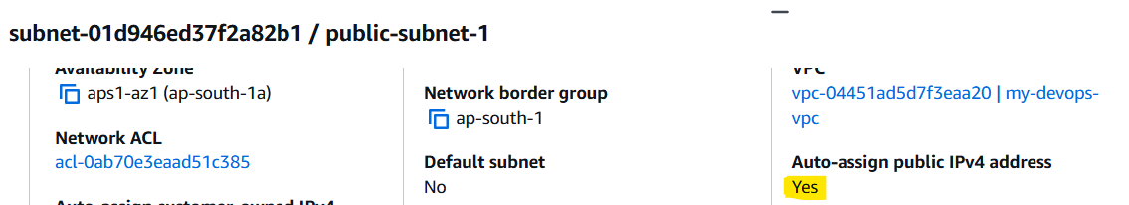

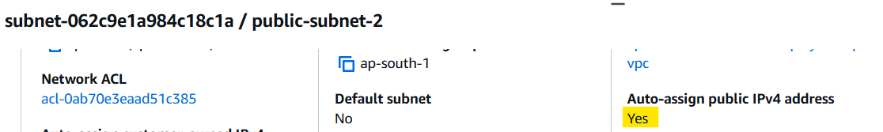

- Add 2 private subnets in private route table..

Objective
Create a private route table and associate both private subnets with it.
Steps Performed
- Navigated to AWS Console → VPC → Route Tables.
- Clicked Create route table.
- Entered the route table name as private-route-table.
- Selected my-devops-vpc.
- Created the private route table.
- Selected private-route-table.
- Opened the Subnet associations section.
- Clicked Edit subnet associations.
- Selected private-subnet-1.
- Selected private-subnet-2.
- Saved the subnet associations.
- Verified that both private subnets were associated with private-route-table.
Associated Subnets
Route Table | Associated Subnets
private-route-table | private-subnet-1
 | private-subnet-2
Result
Successfully created the private route table and associated both private subnets with it.

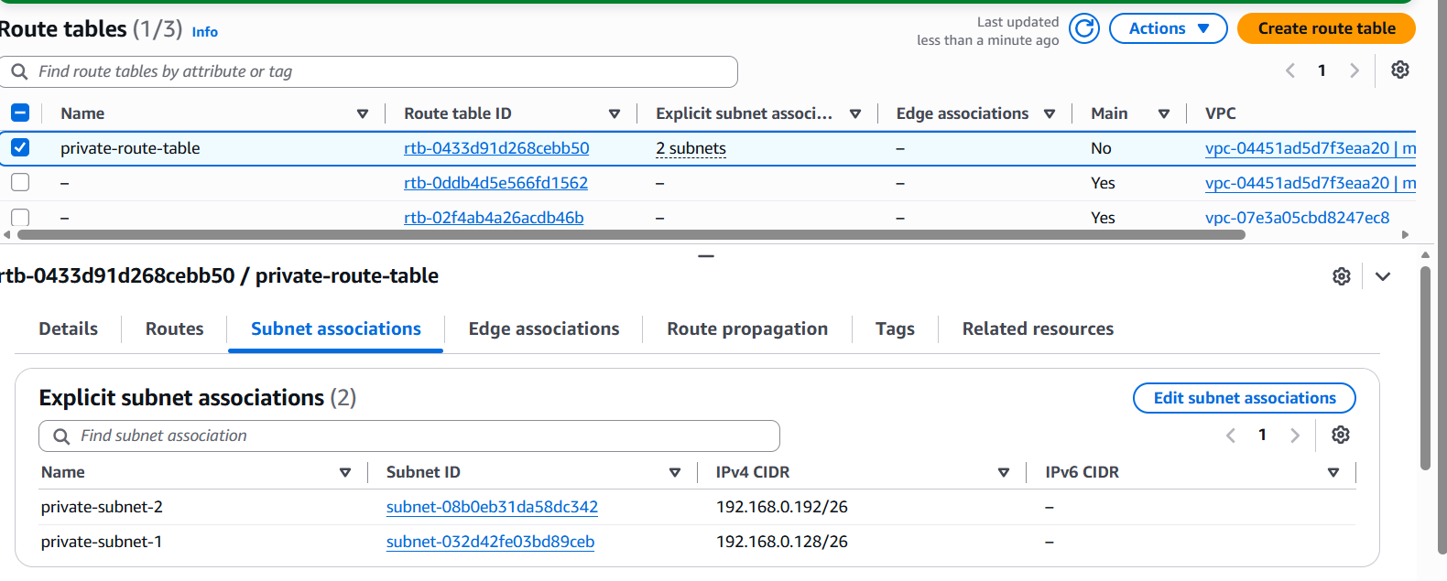

- Add 2 public subnets in public route table..

Objective
Create a public route table and associate both public subnets with it.
Steps Performed
- Navigated to AWS Console → VPC → Route Tables.
- Clicked Create route table.
- Entered the route table name as public-route-table.
- Selected my-devops-vpc.
- Created the public route table.
- Selected public-route-table.
- Opened the Subnet associations section.
- Clicked Edit subnet associations.
- Selected public-subnet-1.
- Selected public-subnet-2.
- Saved the subnet associations.
- Verified that both public subnets were associated with public-route-table.
Associated Subnets
Route Table | Associated Subnets
public-route-table | public-subnet-1
 | public-subnet-2

Result
Successfully created the public route table and associated both public subnets with it.

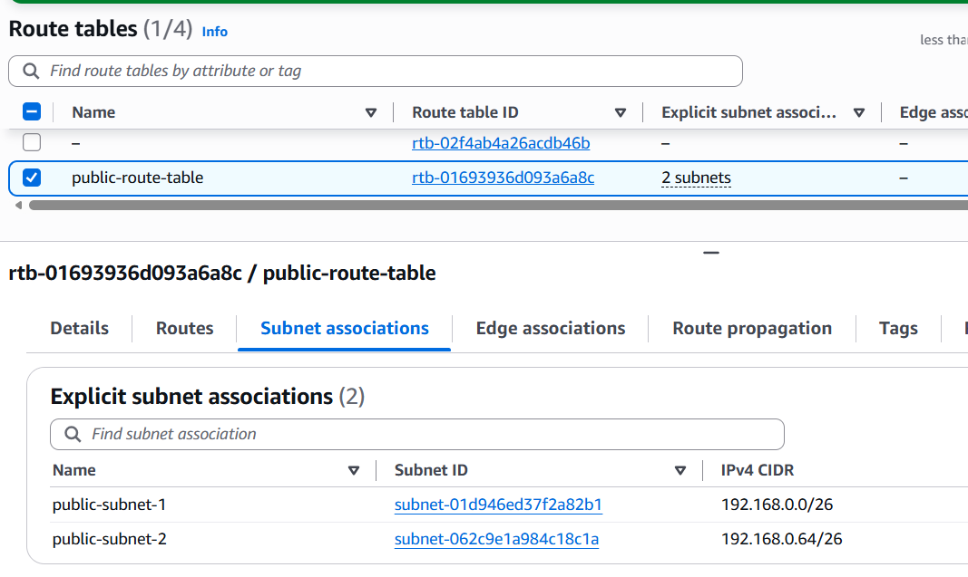
- Public route table will have the routes to internet and local..

Objective
Configure the public route table with a route to the Internet Gateway so that resources in the associated public subnets can communicate with the internet.
Steps Performed
- Navigated to AWS Console → VPC → Internet Gateways.
- Created an Internet Gateway.
- Attached the Internet Gateway to my-devops-vpc.
- Navigated to VPC → Route Tables.
- Selected public-route-table.
- Opened the Routes section.
- Added the following internet route:
Destination | Target
0.0.0.0/0 | Internet Gateway
- Verified that the default local route was also present:
Destination | Target
192.168.0.0/24 | Local
Final Route Configuration
Destination | Target | Purpose
192.168.0.0/24 | Local | Communication within the VPC
0.0.0.0/0 | Internet Gateway | Internet access
Result
Successfully configured the public-route-table with both local VPC routing and internet access through the Internet Gateway.

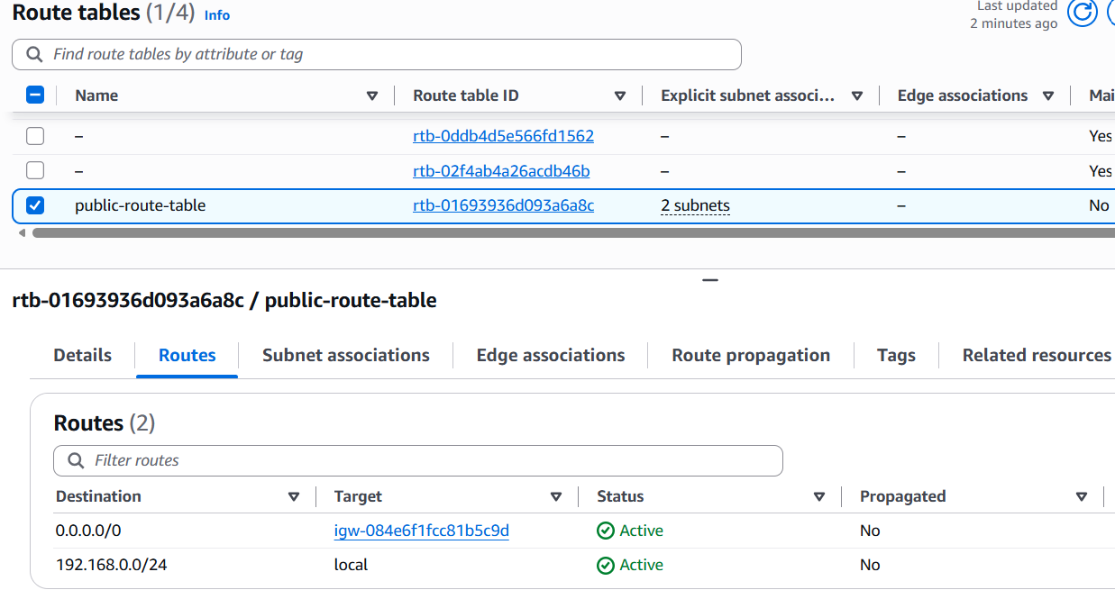

7. Create EC2 in public subnet with t3.micro and install PHP..

Objective
Launch an EC2 instance in a public subnet and install PHP on the instance.

Steps Performed
- Navigated to AWS Console → EC2 → Instances.
- Clicked Launch instance.
- Configured the EC2 instance.
- Selected the instance type:
t3.micro
- Selected the required key pair.
- Configured the network settings:
  - VPC: my-devops-vpc
  - Subnet: public-subnet-1
  - Auto-assign Public IP: Enabled
- Configured the security group to allow:
  - SSH — Port 22
  - HTTP — Port 80
- Launched the EC2 instance.
- Connected to the instance using SSH.
- Updated the system packages:
sudo dnf update -y
- Installed PHP:
sudo dnf install php -y
- Verified the PHP installation:
php --version

Verification
The PHP installation was successful, and the instance displayed:
PHP 8.5.9

Note
The assignment specified t2.micro, but t3.micro was used because t2.micro was not eligible under the current AWS account's available Free Tier options.

Evidence Required
Take screenshots showing:
- EC2 instance running
- Instance type: t3.micro
- Instance launched in public-subnet-1
- Public IPv4 address
- Successful SSH connection
- Output of php --version

Result
Successfully launched a t3.micro EC2 instance in public-subnet-1 and installed PHP 8.5.9 successfully.

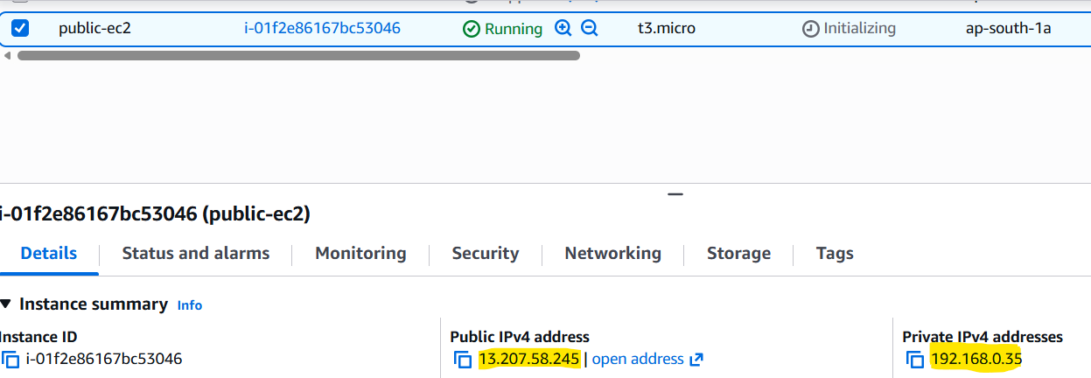

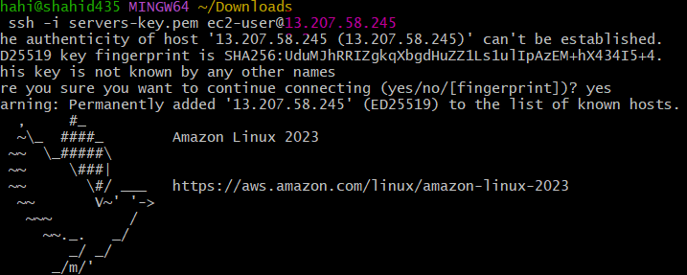
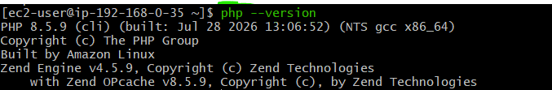

- Configure NAT gateway in public subnet and connect to private instance..

Objective
Configure a NAT Gateway in a public subnet and update the private route table so that instances in the private subnets can access the internet for outbound traffic without having public IP addresses.

Steps Performed
- Allocated an Elastic IP address.
- Navigated to VPC → NAT Gateways.
- Created a NAT Gateway with the following configuration:
  - Name: my-nat-gateway
  - Availability mode: Zonal
  - Subnet: public-subnet-1
  - Connectivity type: Public
  - Elastic IP: Attached the allocated Elastic IP.
- Waited for the NAT Gateway status to become Available.
- Navigated to VPC → Route Tables.
- Selected private-route-table.
- Opened the Routes tab.
- Added the following route:
Destination | Target
0.0.0.0/0 | NAT Gateway
- Verified that the existing local route was present:
Destination | Target
192.168.0.0/24 | Local
- Opened Subnet associations for private-route-table.
- Verified that both private subnets were associated:
  - private-subnet-1
  - private-subnet-2

Final Traffic Flow
Private EC2
↓
Private Subnet
↓
private-route-table
↓
0.0.0.0/0 → NAT Gateway
↓
Public Subnet
↓
Internet Gateway
↓
Internet

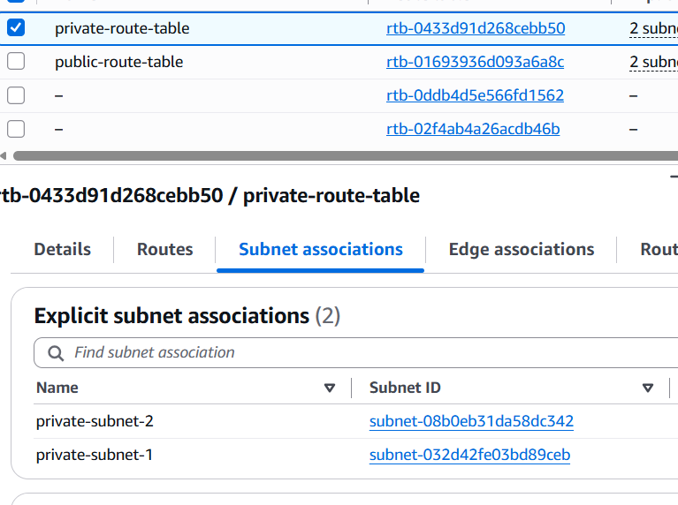

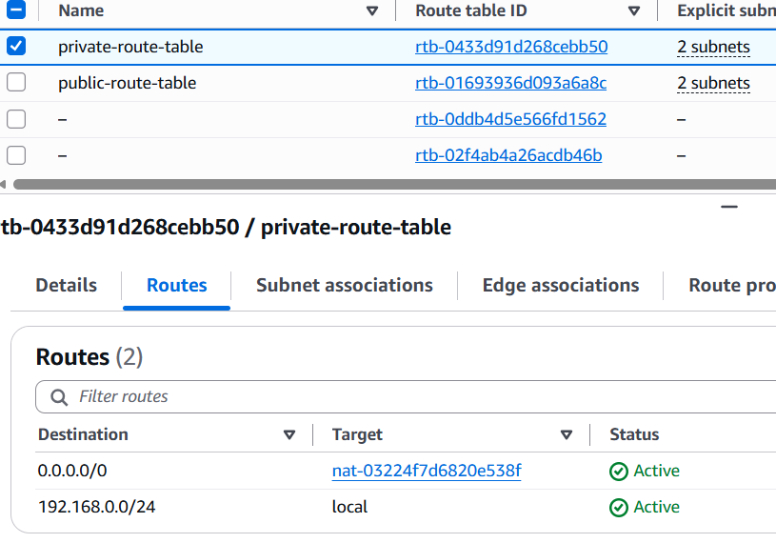

Result
Successfully configured a NAT Gateway and associated both private subnets with a route table that directs outbound internet traffic through the NAT Gateway.

- Install Apache Tomcat in private EC2 and deploy a sample app..

Objective
Launch an EC2 instance in a private subnet, install Java and Apache Tomcat, and deploy a sample web application.
Steps Performed
- Launched an EC2 instance with the following configuration:
  - Instance Name: private-tomcat-ec2
  - VPC: my-devops-vpc
  - Subnet: private-subnet-1
  - Private IP: 192.168.0.140
  - Public IPv4: None
- Connected to the private EC2 through the public EC2 instance using SSH.
- Installed Java:
sudo dnf update -y
sudo dnf install java-17-amazon-corretto -y
- Verified the Java installation:
java -version
Java version installed:
OpenJDK 17.0.20
- Downloaded Apache Tomcat 11.0.25:
cd /opt
sudo wget https://dlcdn.apache.org/tomcat/tomcat-11/v11.0.25/bin/apache-tomcat-11.0.25.tar.gz
- Extracted the Tomcat archive:
sudo tar -xzf /opt/apache-tomcat-11.0.25.tar.gz -C /opt
- Changed ownership of the Tomcat directory:
sudo chown -R ec2-user:ec2-user /opt/apache-tomcat-11.0.25
- Navigated to the Tomcat bin directory:
cd /opt/apache-tomcat-11.0.25/bin
- Started Apache Tomcat:
./startup.sh
- Verified that Tomcat was running and listening on port 8080:
sudo ss -tulnp | grep 8080
The output confirmed that the Java/Tomcat process was listening on port 8080.
- Navigated to the Tomcat web application directory:
cd /opt/apache-tomcat-11.0.25/webapps
- Created a sample application:
mkdir sample-app
vi sample-app/index.html
- Added the following content:
<h1>Tomcat Application Deployed Successfully</h1>
<p>Running from Private EC2 Instance</p>
- Verified the deployed application locally from the private EC2:
curl http://localhost:8080/sample-app/
Architecture
Laptop
│
│ SSH
▼
Public EC2
│
│ SSH
▼
Private EC2
│
▼
Apache Tomcat
Port 8080
│
▼
Sample Application
Evidence Required
Take screenshots showing:
- Private EC2 instance running with no public IPv4 address.
- Successful Java installation using java -version.
- Successful Tomcat download/extraction.
- Tomcat listening on port 8080.
- Successful output from:
curl http://localhost:8080/sample-app/
Result
Successfully launched a private EC2 instance, installed Java 17 and Apache Tomcat 11.0.25, and deployed and verified a sample application running on port 8080.

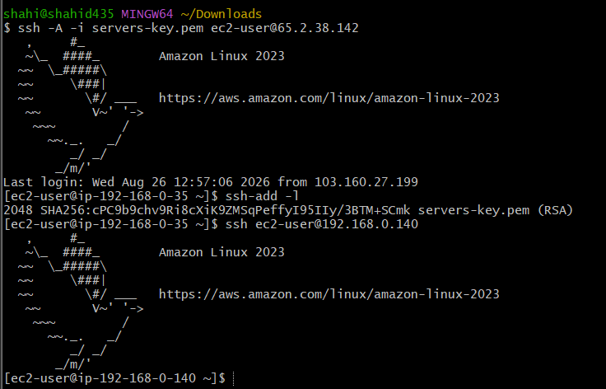

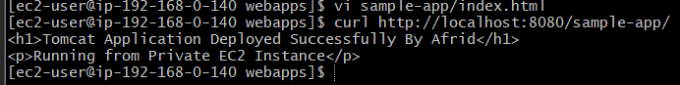

- Configure VPC flow logs and store the logs in S3 and CloudWatch..

Objective
Configure VPC Flow Logs for my-devops-vpc and send the flow log data to both Amazon S3 and Amazon CloudWatch Logs for monitoring and analysis.

Part 1: Configure VPC Flow Logs to Amazon S3
- Navigated to AWS Console → S3.
- Created an S3 bucket for storing VPC Flow Logs.
- Navigated to:
VPC → Your VPCs → my-devops-vpc → Flow logs
- Clicked Create flow log.
- Configured the Flow Log with:
  - Name: vpc-flow-logs-s3
  - Filter: All
  - Destination: Send to an Amazon S3 bucket
  - S3 Bucket ARN: arn:aws:s3:::<your-bucket-name>
  - Log record format: AWS default format
  - Log file format: Text
  - Partition logs: Every 24 hours
- Created the Flow Log.
- Verified that the Flow Log status became Active.

Part 2: Configure VPC Flow Logs to CloudWatch Logs
- Created another Flow Log for the same VPC.
- Configured:
  - Name: vpc-flow-logs-cloudwatch
  - Filter: All
  - Destination: Send to CloudWatch Logs
- Selected or created the required CloudWatch Log Group.
- Under Service access, selected:
Create and use a new service role
- Created the IAM service role:
vpc-flow-logs-cloudwatch-role
- Kept the Log record format as AWS default format.
- Created the Flow Log.
- Verified that its status became Active.

Verification
The VPC should now have two active Flow Logs:
Flow Log Name | Destination | Status
vpc-flow-logs-s3 | Amazon S3 | Active
vpc-flow-logs-cloudwatch | CloudWatch Logs | Active

Result
Successfully configured VPC Flow Logs for my-devops-vpc and configured the logs to be delivered to both Amazon S3 and Amazon CloudWatch Logs.

